The Bosdet Family History 2

The Story Starts 3

In The Beginning 4

The ‘New World’ Connection - Nova Scotia 5

The English Connection 11

Stained Glass Artist 13

Bibliography 14

The Bosdet Family History

‘In summer 880 a young Norwegian heiress, her family involved in a blood feud, was sent up to a mountain farm along with the herds and a few family retainers. Here she was to have her first baby. Later, on returning to her ancestral farm on the western edge of Oslo fjord, she found smoking ruins and everybody dead including her husband. With this, she sold the herd and took a boat south to cousins near present day Caen and eventually bought a farm to the south of Coutances. To throw the feuders off the scent she adopted the name Bjornsdetter (daughter of the bear). The family prospered and over time the name changed to Borsdestre (1450), Borsdest (1560), Bordet (1700) and Bosdet by 1814.’

This lovely story came to Mary Bosdet from a pen friend whose father studied the records of Norwegian families settling in 9th and 10th century Normandy. Details were obtained from French manorial records in Caen, Bayeux and Coutances, which eventually led to a tree being given to Mary’s father along with other documents in 1938. Unfortunately, these records were destroyed during the bombing of London and more importantly, it appears that the French archives were largely destroyed during the Normandy landings and it is very unlikely that the tree, if it was correct, can be reestablished.
The Story Starts

My story starts in the Channel Islands where the majority of my research has been undertaken and where it is readily evident that the Bosdets are of French Huguenot descent. The word Huguenot is the name given to the French Calvinist Protestants of the 16th and 17th centuries.

In its early stages, French Protestantism was largely inspired by Martin Luther and had its chief centre in the Alsatian city of Strasbourg. Through the initial ambivalence of the French crown and the enthusiastic activities of preachers, Protestantism spread rapidly and by 1550, it included among its converts nearly one quarter of all Frenchmen. After that date, the leadership of the movement was increasingly taken over by John Calvin, who sent teams of missionary preachers from Geneva into France.

With the onset of the French Wars of Religion in 1562, the Huguenots emerged not only as a religious movement but also as a highly organized military force. Although they were greatly outnumbered, they managed to hold their own, largely because of the leadership of the substantial number of noblemen who were Huguenots. The bloodshed and atrocities on both sides during these wars culminated in the Saint Bartholomew's Day Massacre (August 24th 1572), when, it is estimated, tens of thousands of Protestants were slaughtered. The wars lapsed after the Protestant Henry IV, who had come to the throne in 1589, nominally converted to Roman Catholicism and issued the Edict of Nantes (1598), creating a de facto cease-fire and a state of partial religious toleration.

During the 17th century the Huguenots saw their power and privileges progressively undermined by the strongly Catholic kings Louis XIII and Louis XIV. In 1628 they lost their last fortified city, guaranteed to them by the Edict of Nantes, when La Rochelle fell to Cardinal Richelieu. In 1685 the Edict of Nantes was revoked, and thousands of Protestants chose to emigrate from France rather than accept Catholicism. Shortly after this date we find the first Bosdets appearing on the Island of Jersey. These Bosdets mainly appeared to be farmers, merchants and mariners and all came from Normandy.

My research over the past 15 years has shown that the family was certainly well travelled, particularly in the last century when, along with other native islanders, they spread both to England and the ‘New World’. It would also appear that the last of the Bosdets left the Channel Islands during or immediately before the Second World War.

In The Beginning

The earliest recorded Bosdet was John who, in 1331, was a ‘Jurat’ in the parish of St. John on Jersey. Jurats were elected head men of the parish and dealt in the day to day affairs of the district, something akin to a council. Thereafter, we have to look to 1698/99 for the next recorded Bosdet (within my current research), where we have the marriage of Jacques Bosdet to Elizabeth Valet. These records give us the clue to the Huguenot origins of the family on Jersey as Jacques’ mother, Jeanne Bausdet (original spelling) was referred to as a refugee from Normandy in the church registers. Her other son Matthieu was living in the parish of Grouville at the time of his wedding and then, in 1723 together with the church register entry recording his burial in St John, the following note was made:

'Matthieu Baudet, French by birth, but who several years ago, bought (or rented) the house and lands formerly occupied by Nicolas Le Marinel, was buried 1 Oct 1723'

It is from Jeanne Bausdet that all the current Bosdets in the Americas, Canada and the UK are descended. The following tree shows the first three generations of the Jersey Bosdets beginning at the end of the seventeenth century. In parish papers, both Abraham and Matthieu are recorded as refugees from France, once again giving further support to probable
Huguenot heritage.

The ‘New World’ Connection - Nova Scotia

The Channel Islands have a long history connected with the ‘New World’. The early pioneers came to Isle Madame, Cape Breton, Nova Scotia seven years after the siege of Louisbourg (1758) and, under their direction, Isle Madame with its town of Arichat became a hub of commerce in Nova Scotia, second only to Halifax. Arichat was important commercially for years, with brigs, brigantines, barques and barquentines constantly loading fish for the Catholic countries of the East and South and lugging back coarse salt, sugars and rums for which those far-off markets were noted. For the most part, the merchants of Isle Madame were Jersey men and of French Huguenot origin.

The following passage illustrates the importance of Arichat just as the first Bosdets arrived:

‘The population of this place is increasing fast; the present number of inhabitants may be estimated at two thousand, consisting principally of Arcadian French, who are engaged in the fisheries and coasting trade.

It is a port of entry under that of Halifax, and must be considered the most important and thriving place in Cape Breton. The town, or rather long village, with its chapels, courthouse, dwelling houses, store, wharves, and fishing craft, has a pleasing, industrious, and trading appearance. The fishery is here conducted to an important extent; and several cargoes of dry cod and pickled fish are annually exported to Spain, Portugal, to the countries within the Mediterranean; to the West Indies, and to Halifax. The mercantile houses, who support this fishery are, with two or three exceptions, managed by people from Guernsey or Jersey.’
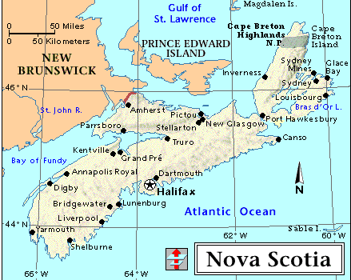

John McGregor in British American (1832) - Vol. I, p.394.

In 1824, the first St. John's Church was established in Arichat. Although the descendants of Jersey ancestry were the predominant number in the parish, many were also of English, Scottish and German origin. The first known Bosdets arrived in Arichat from Jersey around 1842. They were three brothers Peter, Thomas and George. Peter and Thomas were merchants, while George was a mariner.

Their sister Jane, also came to Arichat around the same time with her husband Thomas Martel of Guernsey. They returned to marry in St Peter, Jersey, on Wednesday 19th March 1845 thereafter returning to Nova Scotia, but their life together was short as Jane died in 1851. Her gravestone is situated in the cemetery known as Belle Vue, on the banks of the Straits of Canso, Port Hasting which in her day was called Plaister Cove on Cape Breton Island. The Bosdets and Martels were already related via the Giffard family whose daughters married into the respective families a generation before. Also buried at Belle Vue are two of Jane’s children, Louisa Amanda who died 26th September 1849 and Charles who drowned on the 18th August 1852 aged 1 year 8 months. Could it be that Jane died in childbirth the year before?

Louisa Amanda in fact was only baptised a month before her burial on the 28th August 1849 in St. Johns Church, Arichat, the very same church that the rest of the Bosdet family attended. These families were obviously aware of each other as Peter Bosdet was godfather and Miss Elizabeth Bosdet of Jersey was her godmother along with Mrs Maria Ballaine of Arichat. This Elizabeth was presumably Peter’s sister, but she did not stay long in Arichat for by the 1851 Census she had returned to St Peter, Jersey to live with her brother John and widowed mother. This was followed shortly after by her marriage to Josue de Carteret in 1852.
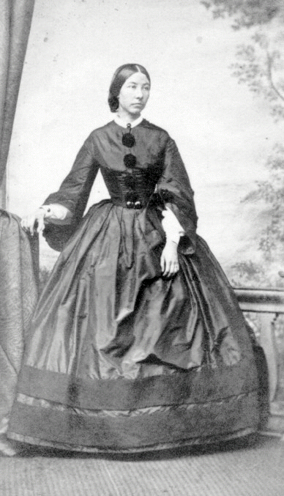

Thomas Martel was a Strait of Canso trader in Canada. From a letter dated 8th November 1847 sent from Plaister Cove, we can see he wished to widen his horizons as he asked to become a seizing officer to prevent smuggling. In addition, his mother Elizabeth Giffard in a letter dated 31st October 1848 to Messrs Samuel Dobree & Sons in London, advised them that her son Thomas Martel was applying for the Lloyds agency in his neighbourhood and he had put them forward as a referee. Thomas finally returned to Guernsey by 1861 after the death of his son Charles bringing with him his two surviving children, Elizabeth Jane and Thomas. Elizabeth was never to marry.

However, Peter and George remained in Nova Scotia and in 1849 were provided with a £385 mortgage on land in Little Arichat by another brother John Bosdet who had a 15-acre farm back in St. Peter, Jersey. Thomas Bosdet witnessed the mortgage document. This mortgage was later discharged in 1856 after John had given Thomas his Power of Attorney in 1855 to collect the mortgage payments on his behalf. George, the mariner, never married and in his will made in 1846 only Peter and Thomas were the beneficiaries.

When Thomas died in 1869, he left to his godson and nephew Charles Henry Bosdet son of his brother Peter, £100 to be invested until Charles was fourteen years old, whereupon he specified that the money was to be put towards his education for a profession or any other business he felt inclined to follow. He also bequeathed his gold watch and chain, microscope, telescope, violin and one of his silver spoons. His other nephew, Peter Cline Bosdet received £50, again to be invested towards his education, this time receiving Thomas’ silver watch and one silver spoon. Peter, Thomas’s brother, received the remainder of his estate and his sister-in-law Mary Anne all his furniture.

Along with five other people, Peter Bosdet owned a small schooner called the "Virgin" a ship of 16 tons which was built at Lennox Passage, Isle Madame, Cape Breton, Nova Scotia in 1844. Perhaps his brother George sailed in her bearing in mind both he and Peter were very close and owned the same land and buildings. The names of Bosdet and Le Lacheur were connected with the fish business in the early days as well as trading as general merchants.

Peter Bosdet became deeply involved in the local Arichat community being a great supporter of St John’s Anglican Church where he is recorded as attending a meeting on Easter Monday, 1861, along with David Gruchy; Dr. Henry C. Fixott; John H. Ballam and William R Cutler, Q.C, the latter being the same William Cutler who witnessed the mortgage release document of Peter and George in 1856. In time, these families became related by marriage. After Peter’s death, they continued to hold services every other Sunday in Peter Cline’s home.

The first Post Office at West Arichat was opened around 1860 and was managed by Peter Bosdet from whose hands it passed to Mr. Emile Mouchet and thence to Capt. A. LeBlanc. West Arichat had two daily mails and sorted all mail for Port Royal, a district two miles away, to where it was carried by coach and also for Janvrin's Island, another district in the same parish, where the coach visited twice a week.

Thomas and George died without offspring, but Peter Bosdet married Mary Ann Fixott, daughter of Dr. Charles Fixott, the first physician in Arichat. Mary Ann was the first of eleven children of Dr. Charles and Tryphosa Elizabeth (Hoyt) Fixott. Peter and Mary Ann lived in West Arichat, and later Arichat, and had 7 children. Peter and Mary Ann were both active in the community, and on November 3, 1860 Peter was appointed Commissioner of Schools for Richmond County, and again for the District of Richmond on January 3, 1866. Later on July 4, 1866 he became Deputy Registrar of births, marriages and deaths for Little Arichat, in Richmond County.

In the last century, hotels and boarding houses operated livery stables, when horse-drawn carriages would meet ships at ports. The "Sea View Hotel" at Arichat, which was operated by the Bosdet family, had a horse-drawn stagecoach, which met out going and incoming ships serving both the South and North sides of Isle Madame and particularly the Grandique Ferry. Peter entered into this trade sometime after 1881 and, following his death on the 20th May 1894, his younger wife Mary Ann (nee Fixott) continued to run the family business along with their son Stanley Clement Victor.

As mentioned earlier, the families were very active in the local St. Johns Anglican Church where there is a stained glass window dedicated to the Bosdet family:

'To the glory of god, and in loving memory of Mary E., Ernest V., George, Thomas, Florence H., Charles H., Peter, Stanley, Cline and Helen Bosdet'

This window must have been ordered by Mary Ann between the death of Cline and Helen in 1905 and Mary Ann’s own passing in 1907. Many of the family members, relatives and friends are buried in the graveyard situated on the hill behind the church. Florence Hoyt, the only daughter of Peter and Mary Ann Bosdet, died of diphtheria when aged 17.

The obituary of Peter Bosdet (25th May, 1894) adds further evidence to his position in the local community:

"In this number we record the death of Peter Bosdet, an old resident of Richmond County and a native of Jersey, who came to this country in the year 1842 and subsequently settled at West Arichat where he conducted a mercantile business in company with his brother Thomas, who died ten years ago. He married, in 1853, Mary Ann, daughter of the late Dr. Charles Fixott of Arichat, and who, of late years has conducted the Sea View hotel in that place. The deceased always took a lively interest in municipal affairs and when his health permitted he was ever ready to give a helping hand in public improvements. He was of a most genial disposition, a true and worthy friend and a most kind and affectionate husband and parent. For the past few years he had been sadly afflicted with rheumatism which caused him to retire from active duties, and although at times, his sufferings were most acute, yet he was never heard to murmur. He had been permitted to reach a good old age and died in peace, and the memory of his work will long be cherished by his many relatives and friends, with whom we sincerely sympathise in their sad bereavement."
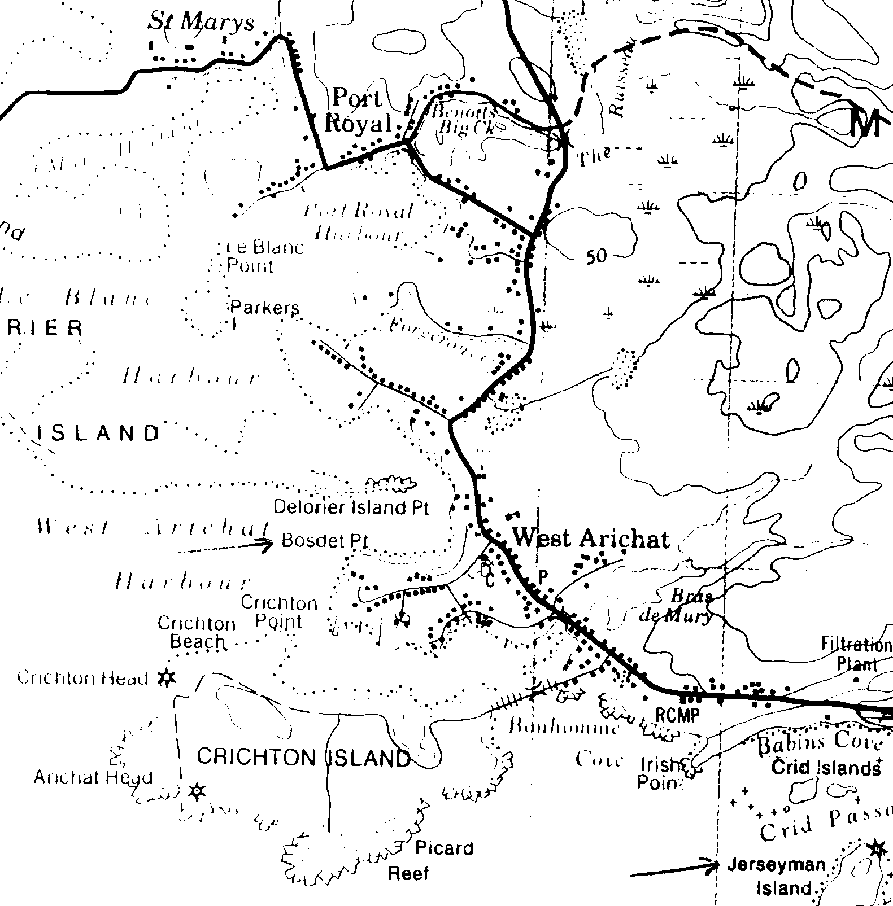

Eastern Journal (John C. Bourinot, Proprietor) of Port Hawkesbury, Cape Breton, Friday May 25, 1894 Vol. V, No. 30.

Two of Peter Bosdet’s children, Peter Cline and Charles Henry, later married and had children. The remaining offspring died as children or young adults. Peter Cline was a successful general merchant employing 14 people by 1891 and lived in a house built for him on Bosdet Point overlooking the ocean in West Arichat. Anna and Joe Samson have beautifully restored the house. The road to Bosdet’s Point is called Chemin des Bosdets or Bosdets Road. Peter Cline married Helen Beatrice Ballam and they had two children, Clina and Griffith. Both parents died when the children were still very young, Helen dying on the 27th July 1905 at the age of 38. Their Aunt Rose Ballam sent Helen Clina for three years to a Catholic Convent in Halifax for boarding and schooling while Rose took care of Griff. Helen Clina spent lonely Christmases at the Convent while other children went home for the holidays. She later grew up with their cousin, Helen Finlayson, whose mother was a twin of Helen Cline's and Griff's mother.

In 1920, Helen Clina Bosdet resided in Sydney, Nova Scotia having reached her majority in the month of December 1919. In the late 1920's she emigrated to Vancouver and lived with her Aunt Rose and Griff who had already moved there in 1912. She became a senior secretary in an office of barristers and solicitors in the city. Clina eventually married Frank Hendrin, a west-coast lumberman, but the couple had no children. Griffith married Peggy and had two children, John and Peter. Peter Bosdet was in the armed forces in Germany and later lived on Isle Madame where he met and married Madeleine Landry. They have two children, Diane and Jason, and live in Grande Cache, Alberta. Griffith retired as a Supervisor with B.C. Hydro Power & Development Corporation Traffic Department in 1970.

Members of the Ballam family were the first telegraph operators in Arichat and the office was in their house where the post office was also located. Roy Ballam was the first postmaster and telegraph operator when the original Federal Government building was erected. He was considered one of the most efficient operators employed by the Western Union Telegraph Company.

After many years of serving as postmaster and telegraph operator he resigned these positions to take up residence in Vancouver, B.C. and was accompanied by his late sister, Miss Rose Ballam, his nephew, the late Griffith Bosdet, and his niece, Clina Bosdet, now Mrs. Hendrin of Vancouver. It was always Roy Ballam's desire to become a steamboat master and after a short time engaged on the Vancouver waterfront where he received his Master's Certificate of Competence. After several years' service as a ship's master, he was tragically lost at sea. The late Captain Roy Ballam was a man of many accomplishments whose ancestors were among the early settlers of Arichat, engaged in both coastal and foreign shipping.

The Ballam family is also well known in Arichat for tapestries made by the Ballam sisters, Maria and Margaret, daughters of John Ballam who first came to Arichat in 1821. These have been sold to collectors in United States and Toronto and were apparently of the highest quality being sold for tens of thousands of dollars.

Charles Henry Bosdet, was the first born son of Peter and attended McGill University where he graduated as an electrical engineer when he was aged around 21. Charles obtained employment with ATT to set up the original telephone links in Mexico. While in Mexico he met and married Susana Miller de Pampillon, the daughter of a Mr. Miller of Manchester England and a Mexican mother. Whilst living in Guadalajara, Mexico in 1884, Charles Henry Bosdet appointed his brother Peter Cline, then living in Arichat, as attorney to receive on his behalf money owed by his father Peter. For the most part, Charles remained in Mexico though the birth of his son Ernesto Tomas occurred in Arichat (22nd September, 1883), so it would appear that the couple did undertake some travelling. In addition to installing telephone links in Mexico, Charles Henry also invented (or imported) a bread slicing machine, invented a tortilla-making machine, imported paraffin to replace tallow then used in Mexican candles, and invested in the mining sector. Charles Henry died in 1893 after a bull owned by friends while pretending to be a bullfighter gored him.

In total, Charles Henry Bosdet had three sons: Ernesto, Charles, and Enrique. Ernesto and Charles were just 9 and 6 years old when Charles Henry died. Three years later, Ernesto and Charles journeyed on their own from Mexico to Cape Breton to stay with their grandmother (Mary Ann) in Arichat.

Notice of the arrival of Ernest and Charles Bosdet at Arichat.

‘Ernest and Charlie Bosdet, children of the late Charlie Bosdet and grandchildren of Mrs. Bosdet of the “Sea View”, arrived here on Thursday from Pueblo, Mexico. Their ages are 12 and 9 years respectively and performed the journey alone.’

“Arichat Jottings” in Bras D’Or Gazette, Wednesday 4th November, 1896, Pg 2.

When their grandmother died, all the grandchildren were left $5000. Both later returned to Mexico. Ernesto Bosdet became head of the Pullman Company in Mexico, married but had no children. His brother, Enrique worked for the Pullman Company as a conductor. He was also an inventor, creating diverse devices including an eye-glass defogger paste, a gasoline “saver” to make Ford cars more fuel efficient, and a call device which could be installed in a coffin and used by the occupant to summon help in the event they were buried alive by mistake. His mother, Susana, who had a fear of being buried alive after once falling unconscious, was the inspiration for this invention and was buried with one installed in her coffin, as were many others in Mexico City at that time. He now lives in Monterey, Mexico with his second wife.

Enrique married Angela Virginia Quiros and they have four children: Virginia, Susana, Carlos and Ernesto. Virginia married Ricardo Luviano, Susana married Francisco Perez, Carlos married Josefina (Finy) Gonzalez, and Ernesto married Julieta Galindo.

Charles Lewis Bosdet, the other son of Charles Henry, trained as a metallurgical engineer, practising his craft in various mines in Mexico. Charles married Marion Bourinot of Arichat, a distant relative, in 1915 but Marion died two years later of an internal infection. There was considerable gossip initiated by the marriage because of the family relationships. However, the connection was not overly close, though they did share one set of great-grandparents, Charles Fixott and Tryphosa Hoyt. After Marion’s passing in 1917, Charles was so despondent that he decided to go to war and end it all and paid his own way back to Nova Scotia to join the army at Halifax. He served for 6 months at the front as a siege artillery gunner. During one battle, a shell landed on his gun emplacement, killing his 5 man crew and leaving Charles with such a badly injured ankle that he was hospitalised in England for 6 months. Whilst in England, he took the opportunity to visit the family homestead in Jersey.

Afterwards to return to Mexico, working for the Fresnillo Mining Company in Zacatecas. He was known as one of the best metallurgists in Mexico and developed various refinements to the flotation process which he never patented but which were adopted by many mines in Mexico. In 1922, Sarah Davis (aged 16) eloped by slipping out of a girl’s school she was attending in Mexico City to meet Charles. Sarah was the elder daughter of George Stewart and Mary Coffman Davis from Pennsylvania, George being a civil engineer laying railroads in northern Mexico. Charles and Sarah had 3 children, George, John and Charles. In the 1930’s, the family left Mexico for Victoria, B.C. where the children finished growing up. In those early years, the family had a motor yacht, the ‘Golondrina’, which they sailed through the inside passage and the Georgia Strait. Charles Lewis Bosdet, Sr. eventually passed away in 1942.

George Bosdet now lives in Victoria with his wife, Blanche (nee Francis). George and Blanche celebrated their 50th wedding anniversary during the first Bosdet family reunion in Vancouver in 1995. John Bosdet lived in Victoria before passing away in 1978. Most of the children and grandchildren of George and John live in British Columbia, with many of John Bosdet’s family still in Victoria. Charles Bosdet, his three sons and their wives now live in California.

Other Jersey Bosdets also decided to travel the world. Alfred Helleur Bosdet, son of Jacques Jean and Marie Anne Le Marquand, travelled to the United States after 1881 with his sister Anna Maria. Before he left Jersey he plied his trade as a painter and glazier, living at 52 Thornfield, St Aubin’s Road, St Lawrence with his mariner brothers Durrell and John Mallet (head of family) and cousin Jane Elizabeth who kept house. Earlier, in 1851, the two brothers were living in St Brelade. On moving to the States, they settled down on the East Coast in Boston, Massachusetts where they owned and managed a very successful boarding house for students at Harvard University. Alfred eventually married Mary Koener from Bavaria, Germany. Alfred had two children Anne and John Alfred who eventually retired to Illinois and Oklahoma respectively. Alfred’s brother was a mariner and I wonder as to whether they sailed together across the Atlantic. Unfortunately, I have not been able to discover what happened to John.

The English Connection

The family of John Philippe Bosdet and Susan Giffard (parents of the Nova Scotia brothers) certainly had a passion for travel. Another son, James lived for a long time with his wife Eliza Speck in Hamburg before finally returning to Jersey. Here at his home 2 Winchester Villas, Winchester Street, St Helier he died on the 22nd March 1871 at the age of 63 after a very long and painful illness. One of his sons, Charles James, was an East India merchant living in Kensington where he married Mary Jane Snart in 1872. When his wife died 3 weeks after the birth of their son Vernon, Charles departed at once for the East Indies and few letters arrived for the next 10 years. A Jersey nurse-maid continued to keep the two boys and herself by letting out rooms in their Ealing Villa until young Charles Gifford William went to work as a clerk at the age of 15. The nursemaid married one of the lodgers who disliked both boys and insisted they lived elsewhere.
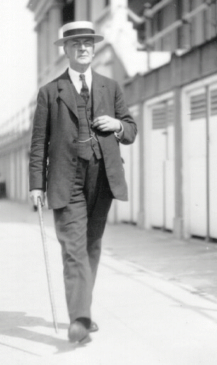

Charles Gifford William went to live with another clerk, whilst Vernon boarded with the Chapman family at the age of 5, the Hughes at age 7, the Chalmers at age 8 for a few months and finally with the Clarks at Richmond. At this point, their father reappeared and insisted that his son Charles Gifford William provide a home for him! With some reluctance Mrs Millie Gunthorpe (aunt) was persuaded to give a home to Vernon. At Charles’ death on the 29th November 1922, his place of residence was given as 80 Lenthall Road, Dalston, where he was still living with his son who later retired as the chief clerk of his firm in 1936 and died in an air raid on London in September 1940.
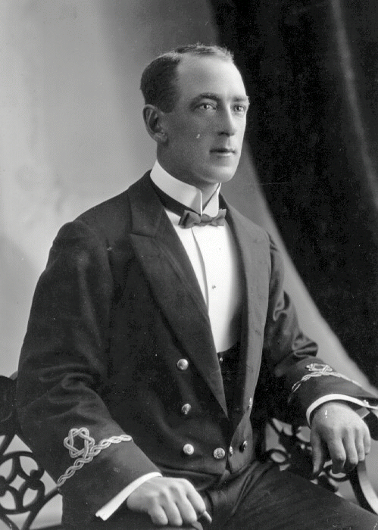

At the age of 11,Vernon’s uncle bought him a place with a shipping company as a cabin boy and from 14 to 17 as an apprentice. He secured his second mates certificate at 19, his first mates at 21 and masters at 24. After two years as a first officer under sail he retook the examination in steamship practice and became the youngest captain in Shaw, Saville & Albion's fleet. In 1904 he married Ellen Mary Ann Bradley whose family lived in Tottenham (next to the Poulters who ran a laundry business). Vernon eventually became a Lieutenant Commander RNVR and served during the First World War between 1915-1918.

In 1924, the shipping line sacked three quarters of its officers and men because of the depression, which lasted until 1932-33. Vernon was out of work from 1926 to 1932 when he became a cargo supervisor at the Royal Albert Docks, London. During September 1940, he was down the hold of a ship when a stick of bombs fell on the docks and he suffered severe concussion. Afterwards he joined the Admiralty in April 1941, at first serving in the Convoy Room. He retired in 1950.

He fell ill with cancer earlier in 1943 and was taken into hospital on V-E Day. Following his wife’s death Ellen Mary Ann (nee Bradley) on V-J Day in 1945, a WRNS friend in her 50's agreed to keep house for Vernon and they moved to her hometown of Lowestoft in 1951 where she also died of cancer in 1957. Vernon then took up a place at the Royal Alfred Merchant Navy Home at Belvedere, Kent where he died on the 28th January 1960.

When the depression started in the late 20's Vernon’s son Jack had just become an apprentice with the Booth Shipping Line. He was out of work from 1929 to 1932 but then resumed work as a second and then a first officer with various companies. Jack died at sea due to enemy action on or after 26th September 1941. He was a Chief Officer (Supernumerary) in the merchant service on the vessel 'Cortes' owned by MacAndrews & Co Ltd. He had been living with his parents at 15 Calton Mansions, Holmleigh Road, London just before he left with the convoy which was off the Bay of Biscay where the ‘Cortes’ and 21 other vessels were also lost.
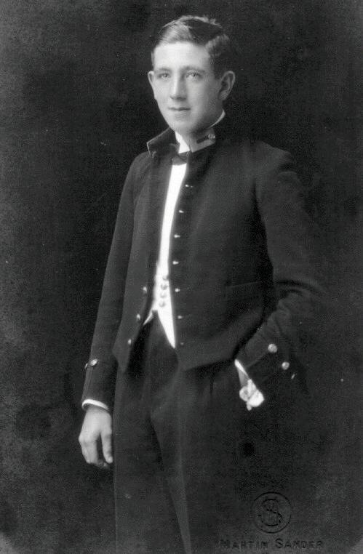

After a secretarial post with the London School of Economics and holding a staff bursary Jack’s sister, Joan Mary Bosdet attended lectures at Kings College, Strand and took her BA(Geography) degree in 1938 and the BSc(Economics) in 1940. She joined the WRNS in September 1940 as a volunteer but was given 6 months deferment because of her father's hospitalisation after the air raid on the docks the same month.

After demobilisation in April 1946, Joan Mary joined the British Council as a Registrar and worked in Czechoslovakia. She also worked as a part-time teacher of English as a foreign language there. In February 1948 Joan became a lecturer in Commerce & Industry at the time of the Communist putsch and was expelled from the country in February 1950 with the remainder of the Council staff leaving by May the same year. Meanwhile she had applied for a post in H M Inspectorate of Schools and was appointed on November 1st 1950 after completing her British Council contract in Wales. She retired finally from the Inspectorate in January 1978, but shortly afterwards became a part-time assessor to the City & Guilds of London Institute and a part-time inspector of Schools of English as a British Council inspector in 1980. She now travels widely, both for these jobs and privately having been around the world 4 times since stopping full-time work.

Stained Glass Artist

Other Bosdets left Jersey for England in the middle of the nineteenth century arriving at the main ports of Bristol, Liverpool and London where the main branches remain to this day. The most famous member of the family is Henry Thomas the son of Captain Thomas Bosdet (Merchant Service) and Sophia Mary Le Roy, his wife. Born in St Helier on the 7th January 1857, he was educated at Boyer's School, Beaumont before leaving the island to study at University College School, London, and the Royal Academy. On leaving the Royal Academy he became Director of an Art School in Islington however, in 1890 he returned to the Royal Academy as Curator of the Life School. During his period in London he lived at Inglewood, Grove Park Terrace, Chiswick, where he had his own workshop.
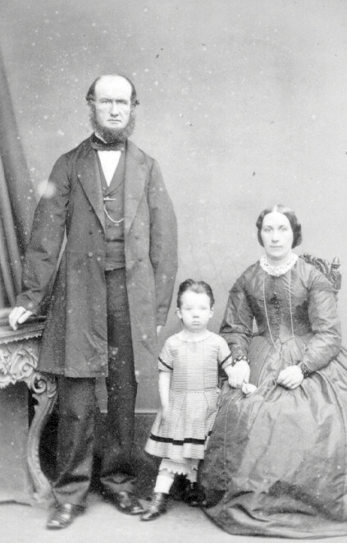

He painted a number of portraits (one of which he exhibited at the Royal Academy of Arts in 1884) and French landscapes, but abandoned this form of art on becoming interested in stained glass through his friendship with Philip Westlake. Among his numerous stained glass windows in England are those of the north transept at Hexham Abbey, Northumberland. His windows outside England include one in the English Church at Dinan and nine in the English Church in Utrecht. Examples of his work in Jersey include seven windows in St Brelade's Church, five in the Fisherman's Chapel illustrating the life of St. Brendon, the Last Supper in St. Lawrence's Church, the Annunciation in St. Helier's, the Marriage at Cana in St. Aubin's, and the reredos in St. Saviour's. His windows at St. Ouen's Manor illustrate heraldically the history of the De Carteret family. Henry’s stained glass has three particular aspects that distinguish his work from other windows seen in churches. Firstly, his economy of leading, which leaves his detail work complete and un-separated. Secondly, his ability to show the great names of the Bible stories as real people and not stylised figures. His faces have expression and each is distinguishable as an individual. But perhaps the most beautiful aspect of his windows are the glorious colours, particularly his blues and reds. These deep translucent colours glow and change with different light and the movement of the sun.

Henry’s work also went beyond Europe. Following the death of Queen Victoria in 1901, a Resolution was passed in the House of Assembly, Barbados on the 29th October, granting the sum of £500 to be spent on providing memorials to Her Majesty. Of this, £100 was to be spent on a commemorative stained glass window to be erected in the Assembly Chamber. The order for this was placed through the Crown Agents, with Henry Thomas, who was the then Director of the Government School of Design in Islington, London. This window was made in his studio in Chiswick and shipped to Barbados early in 1903. Not everyone liked his portrayal of Her Majesty and his work was much criticised in a Debate in the House of Assembly on 8th December.

In 1920 he returned to Jersey and then on to live in the south of France in 1927, but came back again in 1931. He married firstly Mrs. Julia Marion Reece Edwards of London and following her death, Mary Catherine, daughter of William Brereton, M.D. of Queen's College, Galway. By his second marriage he had one son, Harry Westropp who studied at Victoria College, Jersey entering during the third term in 1931. Harry left in 1933 and went to work as a clerk in the Inpot (Jersey equivalent of Customs & Excise). Sadly, he was killed in action in June 1944 acting as a private in the Dorset Regiment. His father Henry Thomas died 10 years earlier at La Patrimoine, St. Lawrence on the 23rd May 1934, and was buried at St. Saviour's.

At least one of Henry Thomas’ canvases remained on Jersey. This is an impression in oils of the Nativity which he painted in 1907 and now hangs below the east window to the rear of the alter in St Saviour’s Church.
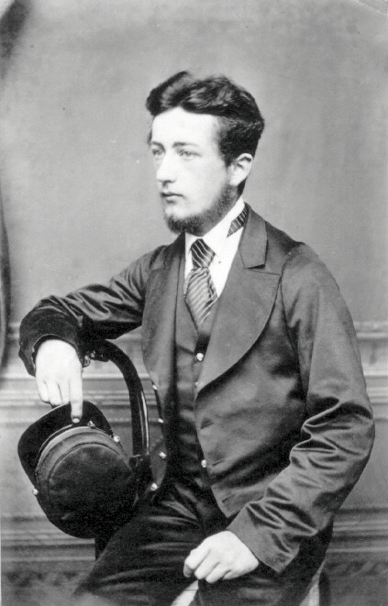

Henry’s father Thomas, was master of the 'Curlew' in 1855 which traded between Jersey and Newfoundland. The merchants Joshua Mauger Nicholle and Isaac Hilgrove Gosset owned this. She was built at La Poile, Newfoundland, 1843 by Edward Namon and was a single deck two masted rigged schooner weighing 21.5 tons, length 41.12m, breadth 12.2m and depth 6.4m. Other owners were given as Philip Winter Nicholle as guardian to the children of John Nicholle deceased and George Thomas Charleton, merchants, together with widows Esther Elizabeth Nicholle and Esther Elizabeth de Quetteville, spinsters Jane Nicholle and Anne Charlotte Nicholle. The vessel was lost in the autumn of 1857. In the 1881 Census, Thomas was still alive, living at Windsor Cottage, Millbrook on Jersey. He was aged 58 at the time and still working as a Ship’s Master.

Philip Nicolle and Co. was the second largest ship owner in the Channel Islands in 1842, just behind the important Robin and Co. In that year they are recorded as having 19 ships totalling 1819 tons, whereas Robin and Co. are recorded as having only 17 vessels but a total of 1997 tons.

Captain Thomas Bosdet’s sister, Mary Anne, married Philippe Gosset who had a grocers shop at 37 Queen Street (next to La Motte Street), St Helier. Her sister Elizabeth was living with them in 1851 and she also worked in the family business.

This completes the story so far - more to come as I delve deeper!

Bibliography

‘Balleine's Biographical Dictionary of Jersey’
‘A People of the Sea’ edited by A G Jamieson
‘Cape Breton Ships and Men’ by John P Parker MBE/Master Mariner
‘St. John's Church of Isle Madame History 1928-1978’ by M. J. Bourinot
Obituary in Eastern Journal (John C. Bourinot, Proprietor) of Port Hawkesbury, Cape Breton
‘Echoes from the Past’ by Marshall J. Bourinot in "The Reporter".
‘History of West Arichat’, 1911 including Martinique,Port Royal, St. Mary's,and Janvrin's Harbour by S.R. LeBlanc
‘Historic Bridgetown’ by Warren Alleque, Barbados National Trust

